Da bi u Locustu simulirao alarme i kvarove, ne radiš samo random telemetry — nego uvodiš:
- abnormalna stanja
- fault injection
- event escalation
- blackout scenarije
- degradaciju kroz vrijeme
To je zapravo “digital twin event simulation”.

Koncept
Normalno stanje:
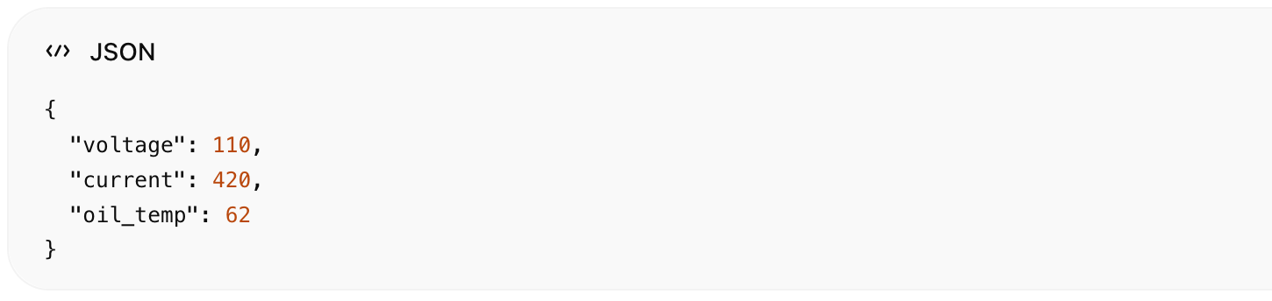
Alarm stanje:
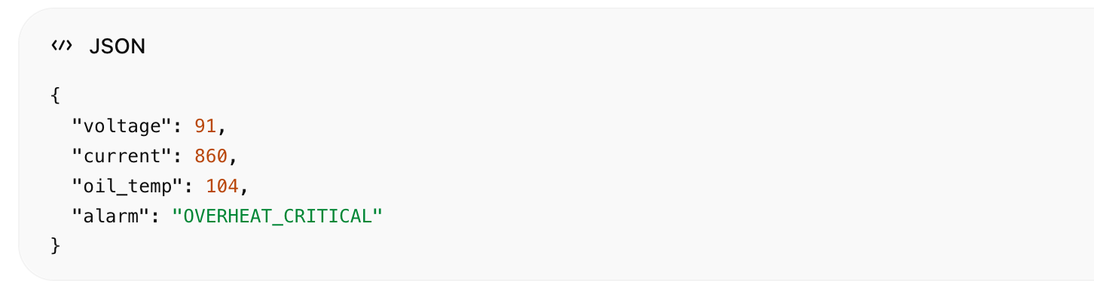

Vrste kvarova koje simuliraš
Fault Type | Primjer
Overload | previsoka struja
Overheating | oil temp > 95°C
Voltage drop | pad napona
Harmonics spike | THD abnormal
Gas anomaly | hydrogen spike
Cooling failure | rapid temp growth
Transformer degradation | lifetime decay
Blackout cascade | overload propagation

Primjer fault injection logike

Ideja
90% vremena:
- normal telemetry
10% vremena:
- fault scenario

Primjer Locust fault simulatora
import random  import time  from locust import User, task  class TransformerSimulator(User):  @task  def send_telemetry(self):  # normal values  voltage = random.uniform(108, 112)  current = random.uniform(300, 500)  oil_temp = random.uniform(55, 75)  hydrogen = random.uniform(20, 80)  alarms = []  # RANDOM FAULT INJECTION  fault = random.random()  # OVERLOAD  if fault < 0.03:  current = random.uniform(700, 1000)  alarms.append("OVERLOAD")  # OVERHEATING  elif fault < 0.06:  oil_temp = random.uniform(95, 120)  alarms.append("OVERHEAT_CRITICAL")  # GAS ANOMALY  elif fault < 0.08:  hydrogen = random.uniform(400, 900)  alarms.append("GAS_ANOMALY")  # VOLTAGE INSTABILITY  elif fault < 0.10:  voltage = random.uniform(85, 95)  alarms.append("VOLTAGE_DROP")  payload = {  "timestamp": time.time(),  "station_id": "TS-001",  "electrical": {  "voltage_kv": voltage,  "current_a": current  },  "thermal": {  "oil_temp_c": oil_temp  },  "oil_gas": {  "hydrogen_ppm": hydrogen  },  "alarms": alarms  }  print(payload) | 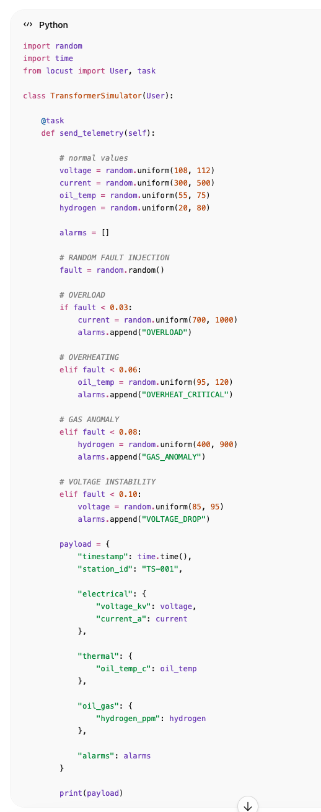

Simulacija degradacije (realnije)
Umjesto random faulta:
kvar raste kroz vrijeme.

Primjer
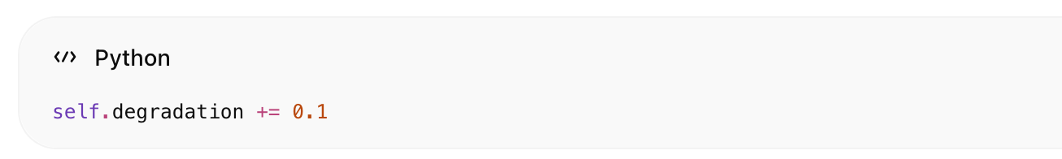
self.degradation += 0.1
Kad degradation prijeđe threshold:
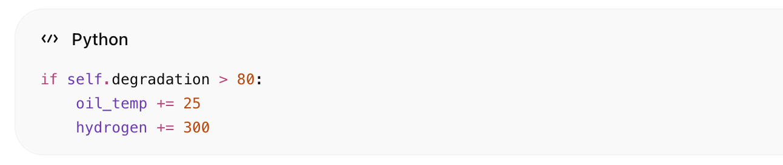
if self.degradation > 80:
oil_temp += 25
hydrogen += 300

Blackout propagation simulation

Jedna trafostanica padne
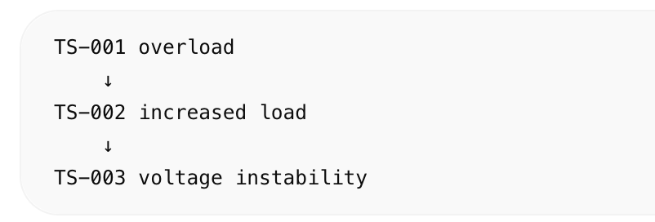

Primjer
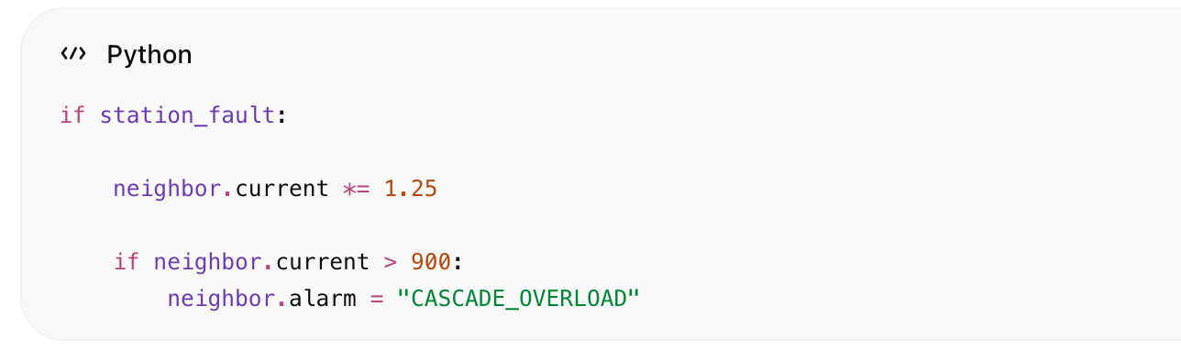
if station_fault:
neighbor.current *= 1.25
if neighbor.current > 900:
neighbor.alarm = "CASCADE_OVERLOAD"

AI anomaly simulation
Možeš generirati:
- subtle anomalies
- noise
- drifting sensors

Primjer drift senzora
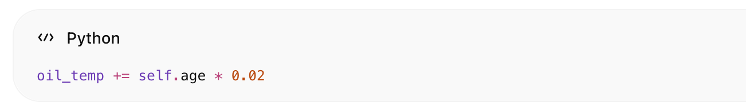
oil_temp += self.age * 0.02

DGA fault simulation (vrlo realno)

Partial discharge
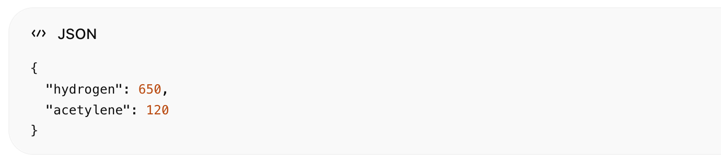
{
"hydrogen": 650,
"acetylene": 120
}

Thermal fault
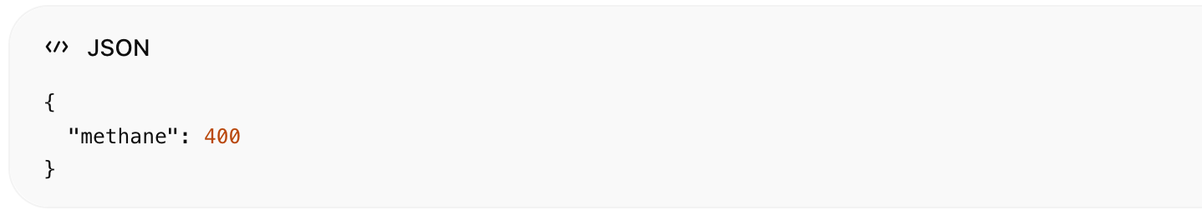
{
"methane": 400
}

Alarm severity simulation
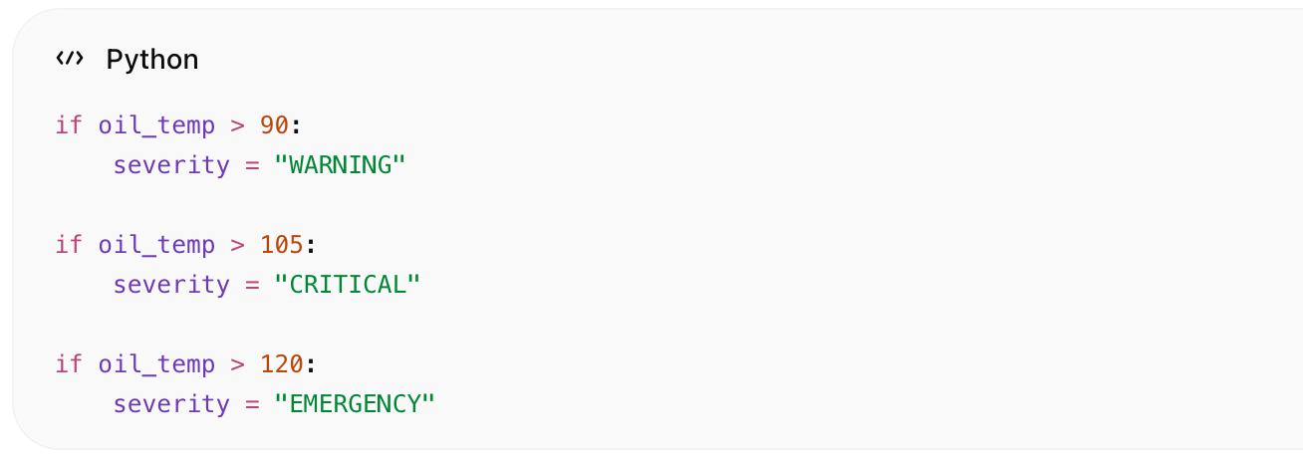
if oil_temp > 90:
severity = "WARNING"
if oil_temp > 105:
severity = "CRITICAL"
if oil_temp > 120:
severity = "EMERGENCY"

Dynamic scenarios

Heatwave
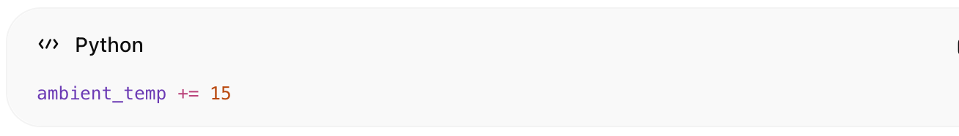
ambient_temp += 15

Peak consumption
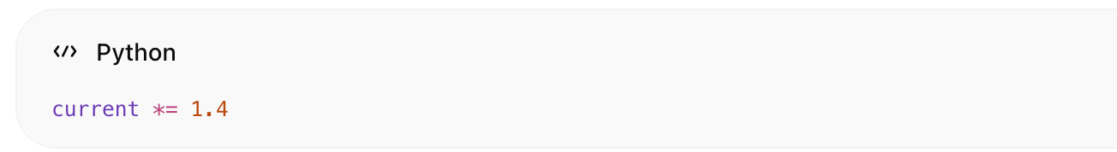
current *= 1.4

Cooling fan failure
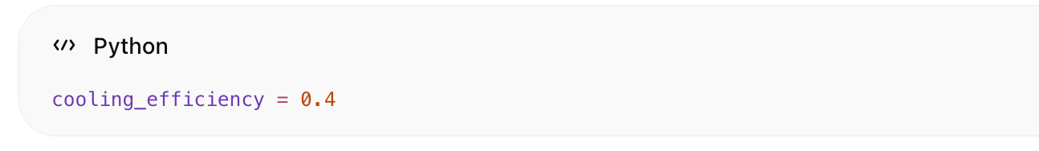
cooling_efficiency = 0.4

Realistic utility behavior

Dan/noć load curve
Noću:
Dan:
Peak:

Realtime flow
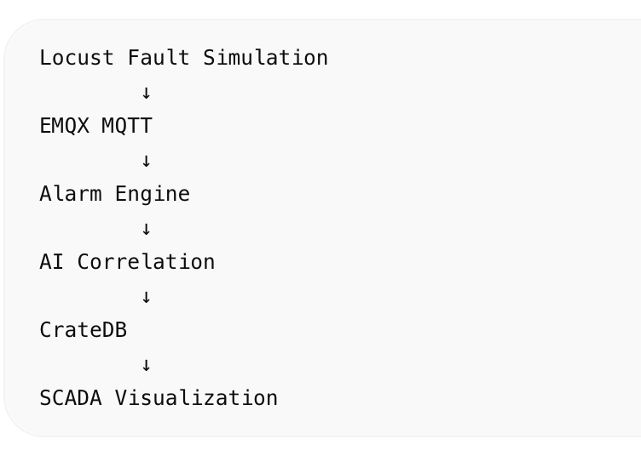

Rezultat
Dobivaš:
- realistične kvarove
- cascading failures
- AI anomaly training data
- predictive maintenance dataset
- SCADA alarm scenarios
- Digital Twin stress testing

